7th Grade Reading Comprehension Worksheets

The reading comprehension passages below include seventh grade appropriate reading passages and related questions. Please use any of the printable worksheets (you may duplicate them) in your classroom or at home. Just click on the worksheet title to view details about the PDF and print or download to your computer.

Anne of Avonlea
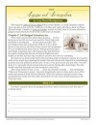
Your student will practice citing supporting evidence with a passage from “Anne of Avonlea.”
Grade Levels: 6th - 8th Grade, Grades K-12
CCSS Code(s): RL.7.1

Biography of Abraham Lincoln
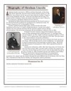
Your student can read about the life of Abraham Lincoln and write a short summary in this worksheet.
Grade Levels: 6th - 8th Grade, Grades K-12
CCSS Code(s): RI.7.2

Coyote: the Survivor of North America
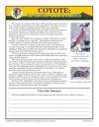
Your student will read a short informational passage about the coyote and then practice finding supporting evidence.
Grade Levels: 6th - 8th Grade, Grades K-12
CCSS Code(s): RI.7.2

Earthquakes
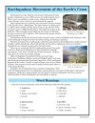
Your student will determine the contextual meaning of words in this informative passage about earthquakes.
Grade Levels: 6th - 8th Grade, Grades K-12
CCSS Code(s): RI.7.2

Grand Canyon
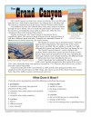
Your student will learn about the Grand Canyon and determine the meanings of words in the passage.
Grade Levels: 6th - 8th Grade, Grades K-12
CCSS Code(s): RI.7.4

Oliver Twist
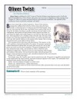
Your student will summarize a passage from Charles Dicken’s classic novel, “Oliver Twist” in this worksheet.
Grade Levels: 6th - 8th Grade, Grades K-12
CCSS Code(s): RL.7.2

The Attack on Pearl Harbor
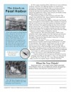
In this worksheet, your student will be asked to analyze the influence of the attack on Pearl Harbor on Americans.
Grade Levels: 6th - 8th Grade, Grades K-12
CCSS Code(s): RI.7.3

The Jabberwocky
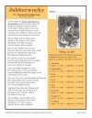
In this worksheet, your student will analyze the fun nonsense words in Lewis Carroll’s “The Jabberwocky” and determine whether the word is a noun, adjective or verb.
Grade Levels: 6th - 8th Grade, Grades K-12
CCSS Code(s): RL.7.4

The Prince and the Pauper
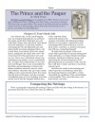
In this worksheet on Mark Twain’s “The Prince and the Pauper,” your student will compare the settings of Tom Canty’s real life and dream life.
Grade Levels: 6th - 8th Grade, Grades K-12
CCSS Code(s): RL.7.3

The Road Not Taken
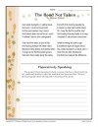
Your student will explore the figurative language in Robert Frost’s beautiful poem, “The Road Not Taken.”
Grade Levels: 6th - 8th Grade, Grades K-12
CCSS Code(s): RL.7.4

